**Garage Management System**

The Garage Management System is a valuable tool for automotive repair facilities, helping them deliver top-notch service, increase operational efficiency, and build lasting customer relationships. With its user-friendly interface and powerful features, GMS empowers garages to thrive in a competitive market while ensuring a seamless and satisfying experience for both customers and staff.The **Garage Management System (GMS)** is a comprehensive software solution designed to streamline and optimize the operations of automotive repair facilities, service centers, and garages. It provides an array of features tailored to meet the needs of mechanics, service advisors, and business owners, ensuring smoother workflows and higher customer satisfaction.

The **Garage Management System** is a valuable tool for automotive repair facilities, helping them deliver top-notch service, increase operational efficiency, and build lasting customer relationships. With its user-friendly interface and powerful features, GMS empowers garages to thrive in a competitive market while ensuring a seamless and satisfying experience for both customers and staff.The Garage Management System (GMS) is a comprehensive software solution designed to streamline and optimize the operations of automotive repair facilities, service centers, and garages. It provides an array of features tailored to meet the needs of mechanics, service advisors, and business owners, ensuring smoother workflows and higher customer satisfaction.

● **Appointment Scheduling:**

1. Simplifies the booking process for customers.
2. Enables staff to manage daily schedules efficiently, reducing downtime and improving resource allocation.

● **Vehicle Management:**

1. Maintains detailed records of vehicles, including service history, repairs, and maintenance schedules.
2. Tracks vehicle status during servicing for better communication with customers.

● **Customer Relationship Management (CRM):**

1. Stores customer details and preferences.
2. Sends service reminders, follow-ups, and promotional offers to build loyalty.

● **Inventory and Spare Parts Management:**

1. Tracks spare parts stock levels, automates reorder processes, and prevents stockouts.
2. Ensures that mechanics always have the necessary tools and parts on hand.

● **Billing and Invoicing:**

1. Generates professional invoices quickly and accurately.
2. Supports multiple payment methods, discounts, and tax calculations.

● **Work Order Management**:

1. Creates detailed work orders with a list of tasks, estimated costs, and timelines.
2. Helps staff prioritize jobs and ensures timely completion.

● **Reporting and Analytics:**

1. Provides insights into key performance indicators like revenue, job completion rates, and customer feedback.
2. Helps identify trends and areas for improvement.

**Salesforce**

**Introduction:**

Are you new to Salesforce? Not sure exactly what it is, or how to use it? Don’t know where you should start on your learning journey? If you’ve answered yes to any of these questions, then you’re in the right place. This module is for you.

Welcome to Salesforce! Salesforce is game-changing technology, with a host of productivity boosting features, that will help you sell smarter and faster. As you work toward your badge for this module, we’ll take you through these features and answer the question, “What is Salesforce, anyway?”.

**What Is Salesforce?**

Salesforce is your customer success platform, designed to help you sell, service, market, analyze, and connect with your customers.

Salesforce has everything you need to run your business from anywhere. Using standard products and features, you can manage relationships with prospects and customers, collaborate and engage with employees and partners, and store your data securely in the cloud.

So what does that really mean? Well, before Salesforce, your contacts, emails, follow-up tasks, and prospective deals might have been organized something like this: https://youtu.be/r9EX3lGde5k

**Creating Developer Account**:

**Creating a developer org in salesforce**.

1. 1. Go to https://developer.salesforce.com/signup
2. 2. On the sign up form, enter the following details :
3. First name & Last name
4. Email
5. Role : Developer
6. Company : College Name
7. County : India
8. Postal Code : pin code
9. Username : should be a combination of your name and company

This need not be an actual email id, you can give anything in the format : username@organization.com

Click on sign me up after filling these.

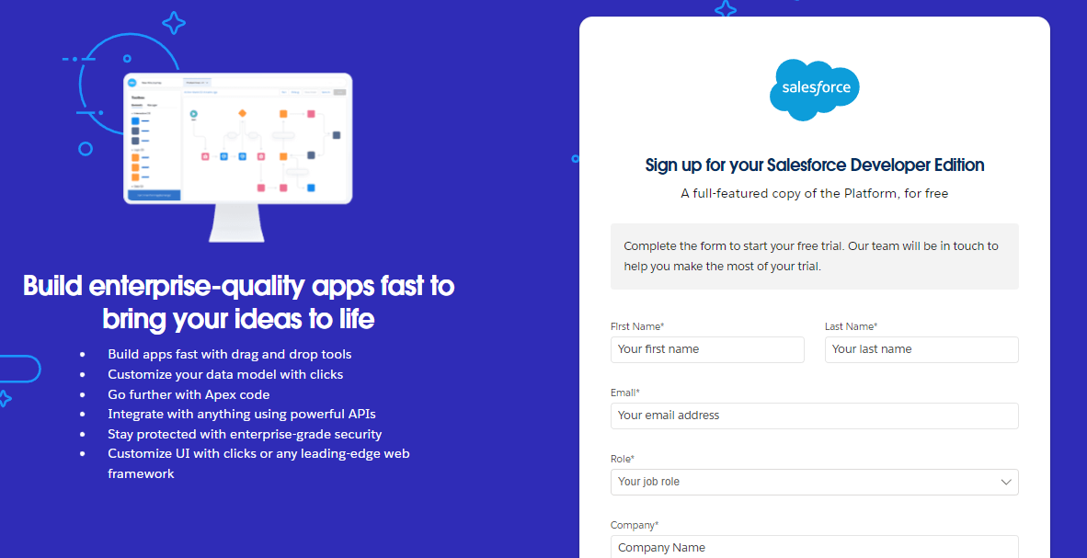

**Account Activation**

Go to the inbox of the email that you used while signing up. Click on the verify account to activate your account.

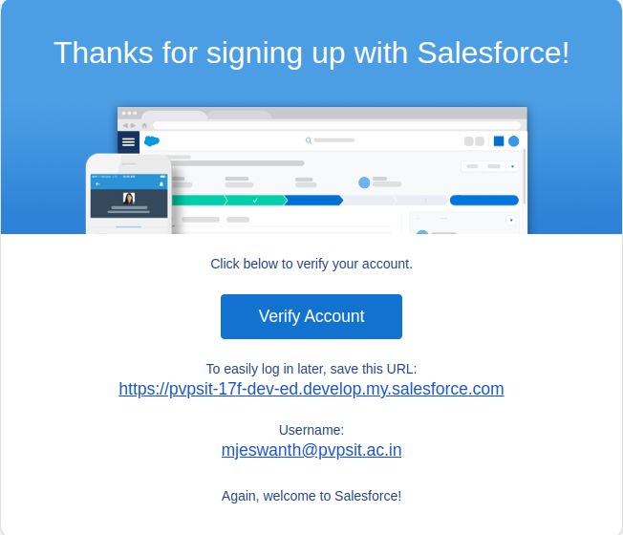

**OBJECT**

**What Is an Object?**

Salesforce objects are database tables that permit you to store data that is specific to an organization. What are the types of Salesforce objects. Salesforce objects are of two types:

1. **Standard Objects:** Standard objects are the kind of objects that are provided by salesforce.com such as users, contracts, reports, dashboards, etc.
2. **Custom Objects:** Custom objects are those objects that are created by users. They supply information that is unique and essential to their organization. They are the heart of any application and provide a structure for sharing data.

**Create Customer DetailsObject**

**To create an object:** From the setup page >> Click on Object Manager >> Click on Create >> Click on Custom Object.

1. Enter the label name >> Customer Details
2. Plural label name >> Customer Details
3. Enter Record Name Label and Format
4. Record Name >> Customer Name
5. Data Type >> Text
6. Click on Allow reports and Track Field History,
7. Allow search >> Save.

**Create Appointment Object**

**To create an object:** From the setup page >> Click on Object Manager >> Click on Create >> Click on Custom Object.

1. Enter the label name >> Appointment
2. Plural label name >> Appointments
3. Enter Record Name Label and Format
4. Record Name >> Appointment Name
5. Data Type >> Auto Number
6. Display Format >> app-{000}
7. Starting number >> 1
8. Click on Allow reports and Track Field History,
9. Allow search >> Save.

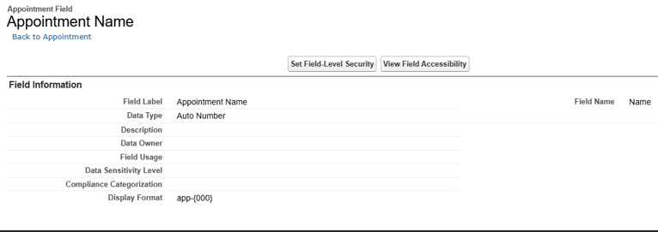

**Create Service records Object**

**To create an object:** From the setup page >> Click on Object Manager >> Click on Create >> Click on Custom Object.

1. Enter the label name >> Service records
2. Plural label name >> Service records
3. Enter Record Name Label and Format

* Record Name >>Service records Name
* Data Type >> Auto Number
* Display Format >> ser-{000}
* Starting number >> 1

1. Click on Allow reports and Track Field History,
2. Allow search >> Save.

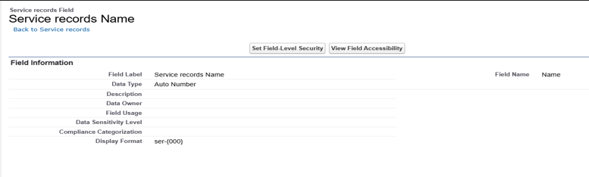

**Create Billing details and feedback Object**

To create an object: From the setup page >> Click on Object Manager >> Click on Create >> Click on Custom Object.

1. Enter the label name >> Billing details and feedback
2. Plural label name >> Billing details and feedback
3. Enter Record Name Label and Format
4. Record Name >> Billing details and feedback Name
5. Data Type >> Auto Number
6. Display Format >> bill-{000}
7. Starting number >> 1
8. Click on Allow reports and Track Field History,
9. Allow search >> Save.

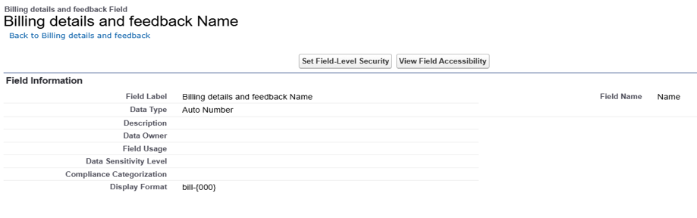

**Tabs**

**What is Tab :** A tab is like a user interface that is used to build records for objects and to view the records in the objects.

**Types of Tabs:**

1. **Custom Tabs** Custom object tabs are the user interface for custom applications that you build in salesforce.com. They look and behave like standard salesforce.com tabs such as accounts, contacts, and opportunities.
2. **Web Tabs** Web Tabs are custom tabs that display web content or applications embedded in the salesforce.com window. Web tabs make it easier for your users to quickly access content and applications they frequently use without leaving the salesforce.com application.
3. **Visualforce Tabs** Visualforce Tabs are custom tabs that display a Visualforce page. Visualforce tabs look and behave like standard salesforce.com tabs such as accounts, contacts, and opportunities.
4. **Lightning Component Tabs** Lightning Component tabs allow you to add Lightning components to the navigation menu in Lightning Experience and the mobile app.
5. **Lightning Page Tabs** Lightning Page Tabs let you add Lightning Pages to the mobile app navigation menu. Lightning Page tabs don't work like other custom tabs. Once created, they don't show up on the All Tabs page when you click the Plus icon that appears to the right of your current tabs. Lightning Page tabs also don't show up in the Available Tabs list when you customize the tabs for your apps.

**Creating a Custom Tab**

To create a Tab:(Customer Details)

1. Go to setup page >> type Tabs in Quick Find bar >> click on tabs >> New (under custom object tab)
2. Select Object(Customer Details) >> Select the tab style >> Next (Add to proles page) keep it as default >> Next (Add to Custom App) uncheck the include tab .
3. Make sure that the Append tab to users' existing personal customizations is checked. Click save.

**Creating Remaining Tabs**

1. Now create the Tabs for the remaining Objects, they are “ Appointments, Service records,Billing details and feedback”.
2. Follow the same steps as mentioned in Activity -1 .

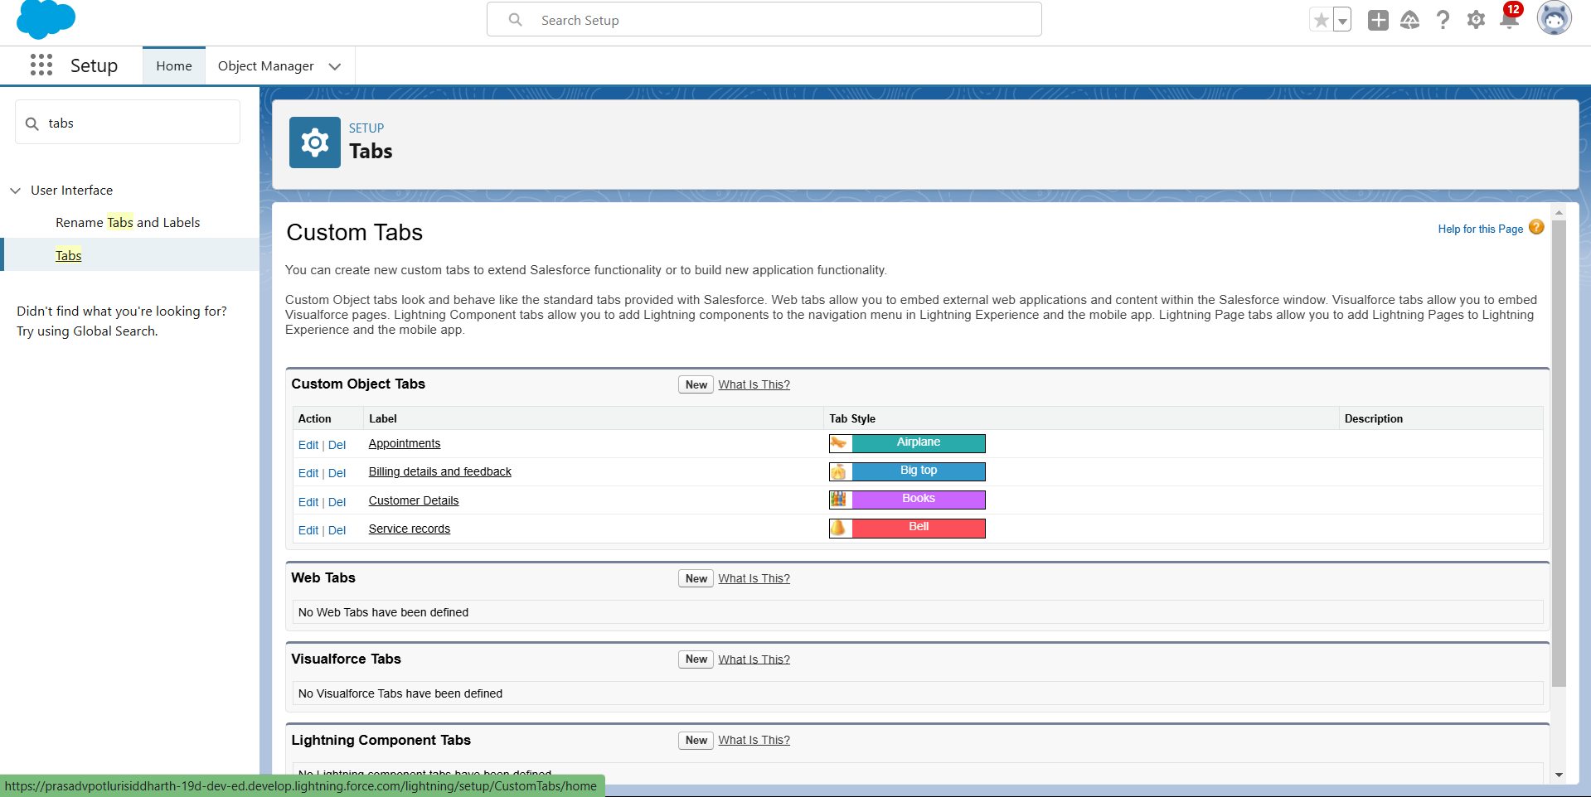

**The Lightning App**

An app is a collection of items that work together to serve a particular function. In Lightning Experience, Lightning apps give your users access to sets of objects, tabs, and other items all in one convenient bundle in the navigation bar.

Lightning apps let you brand your apps with a custom colour and logo. You can even include a utility bar and Lightning page tabs in your Lightning app. Members of your org can work more efficiently by easily switching between apps.

**Create a Lightning App**

**To create a lightning app page:**

1. Go to setup page >> search “app manager” in quick find >> select “app manager” >> click on New lightning App.
2. Fill the app name in app details as Garage Management Application >> Next >> (App option page) keep it as default >> Next >> (Utility Items) keep it as default >> Next.
3. To Add Navigation Items:
4. Select the items (Customer Details,Appointments, Service records, Billing details and feedback, Reports and Dashboards) from the search bar and move it using the arrow button >> Next.
5. To Add User Proles: Search proles (System administrator) in the search bar >> click on the arrow button >> save & Finish.

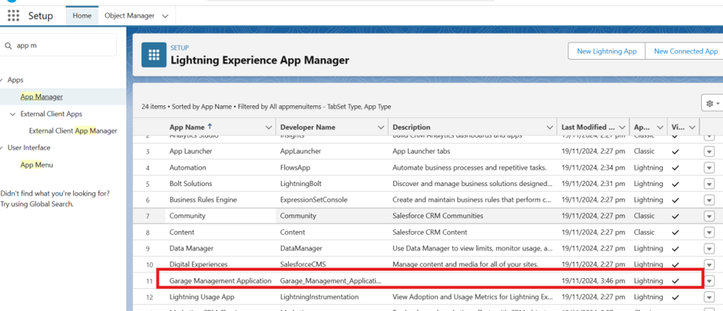

**Fields**

When we talk about Salesforce, Fields represent the data stored in the columns of a relational database. It can also hold any valuable information that you require for a specific object. Hence, the overall searching, deletion, and editing of the records become simpler and quicker.

**Types of Fields**

1. Standard Fields
2. Custom Fields

**Creation of elds for the Customer Details object**

1. To create elds in an object:
2. Go to setup >> click on Object Manager >> type object name(Customer Details) in search bar >> click on the object.
3. Now click on “Fields & Relationships” >> New
4. Select Data Type as a “Phone”
5. Click on next.
6. Fill the Above as following:
7. Field Label: Phone number
8. Field Name : gets auto generated
9. Click on Next >> Next >> Save and new.

Note: Follow the above steps for the remaining eld for the same object.

1. To create another elds in an object:
2. Go to setup >> click on Object Manager >> type object name(Customer Details) in search bar >> click on the object.
3. Now click on “Fields & Relationships” >> New
4. Select Data type as a “Email” and Click on Next
5. Fill the Above as following:
6. Field Label : Gmail
7. Field Name : gets auto generated
8. Click on Next >> Next >> Save and new.

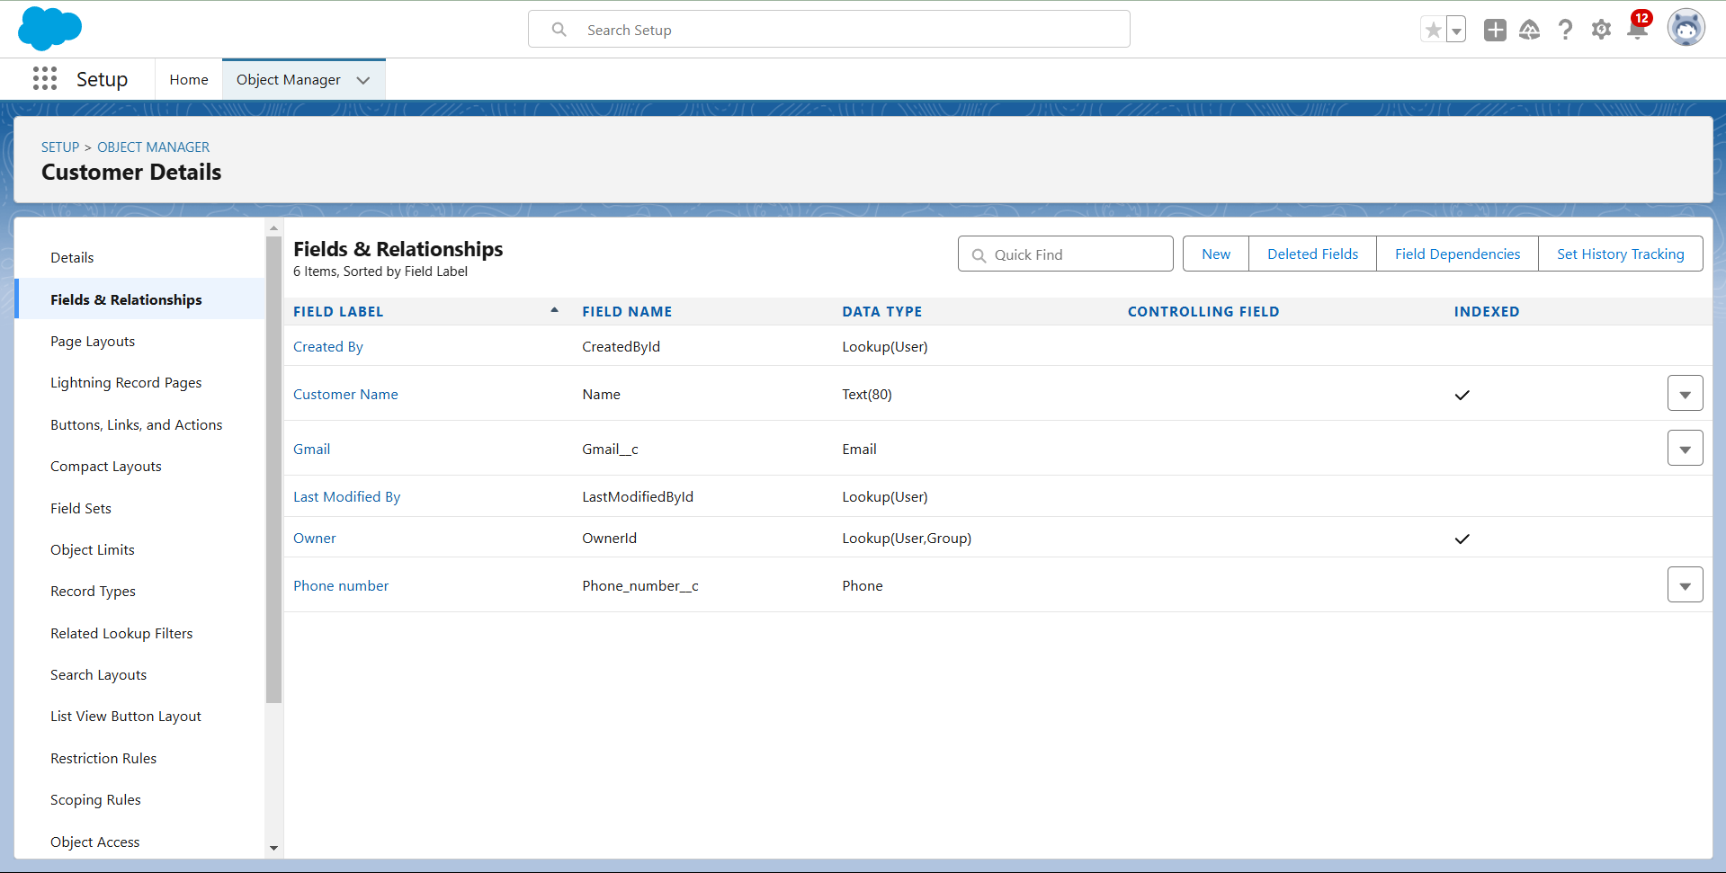

**Creation of Lookup Fields**

**Creation of Lookup Field on Appointment Object :**

1. Go to setup >> click on Object Manager >> type object name( Appointment ) in the search bar >> click on the object.
2. Now click on “Fields & Relationships” >> New
3. Select “Look-up relationship” as data type and click Next. 4. Select the related object “ Customer Details” and click next.
4. Next >> Next >> Save.

Note: Make sure you complete Activity 4 Before continuing.

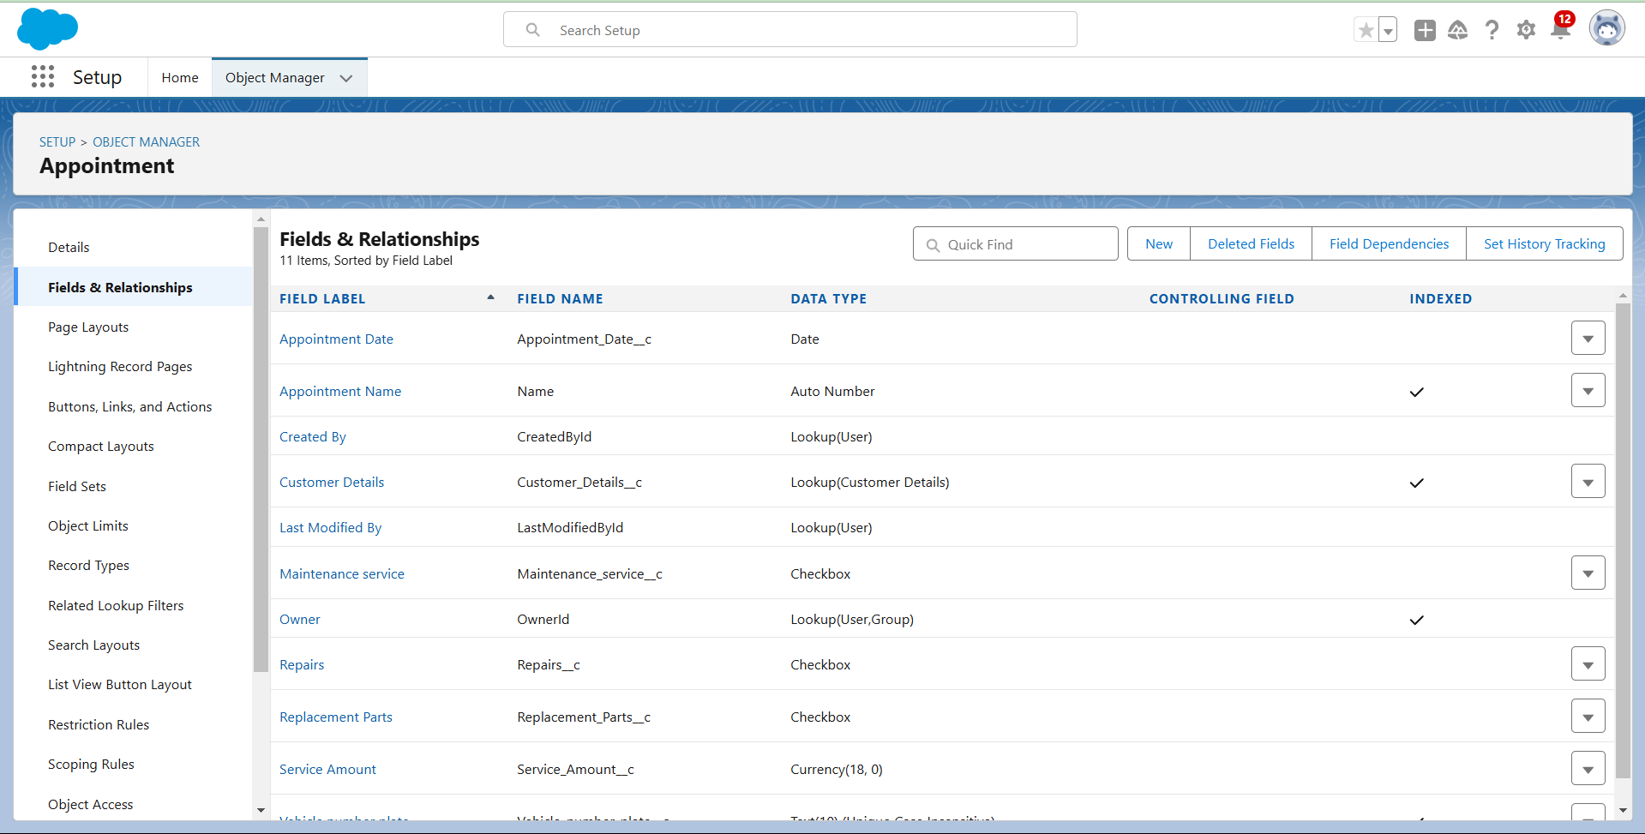

**Creation of Lookup Field on Service records Object :**

1. Go to setup >> click on Object Manager >> type object name( Service records ) in search bar >> click on the object.
2. Now click on “Fields & Relationships” >> New
3. Select “Look-up relationship” as data type and click Next.
4. Select the related object “ Appointment ” and click next.
5. Make it a required eld so click on Required.
6. Scroll down for Lookup Filter and click on Show filter settings.
7. Now add the filter criteria.
8. Field : Appointment: Appointment Date >> Operator : less than >> select eld >> Appointment: Created Date
9. Filter type should be Required.
10. Error Message : Value does not match the criteria.
11. Enable the filter by clicking on Active.
12. Next >> Next >> Save.

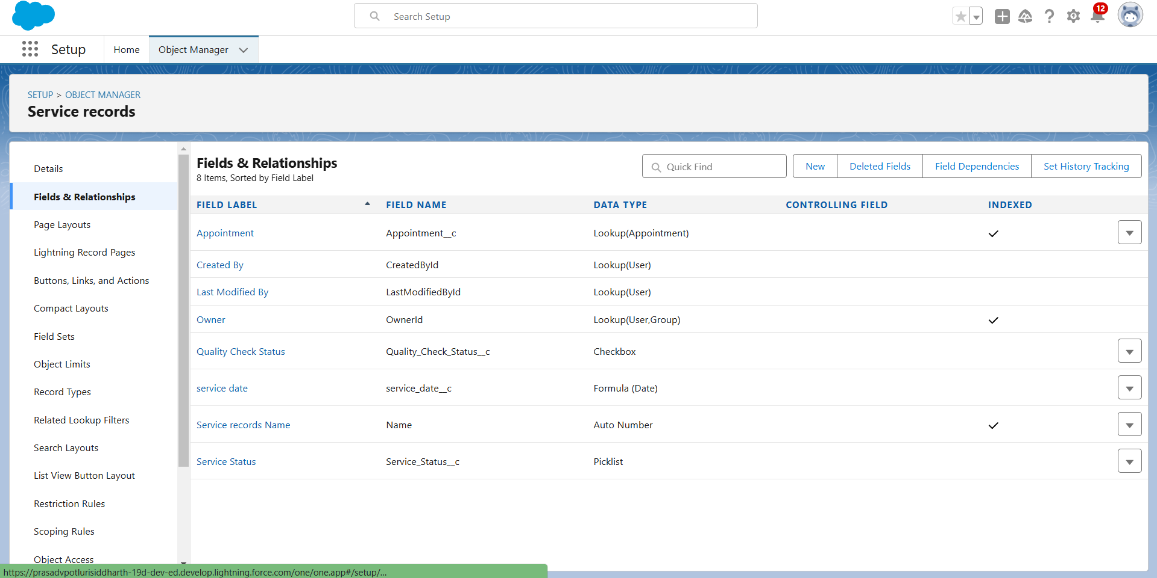

**Creation of Lookup Field on Billing details and feedback Object :**

1. Go to setup >> click on Object Manager >> type object name( Billing details and feedback ) in search bar >> click on the object.
2. Now click on “Fields & Relationships” >> New.
3. Select “Look-up relationship” as data type and click Next.
4. Select the related object “ Service records” and click next.
5. Next >> Next >> Save & new.

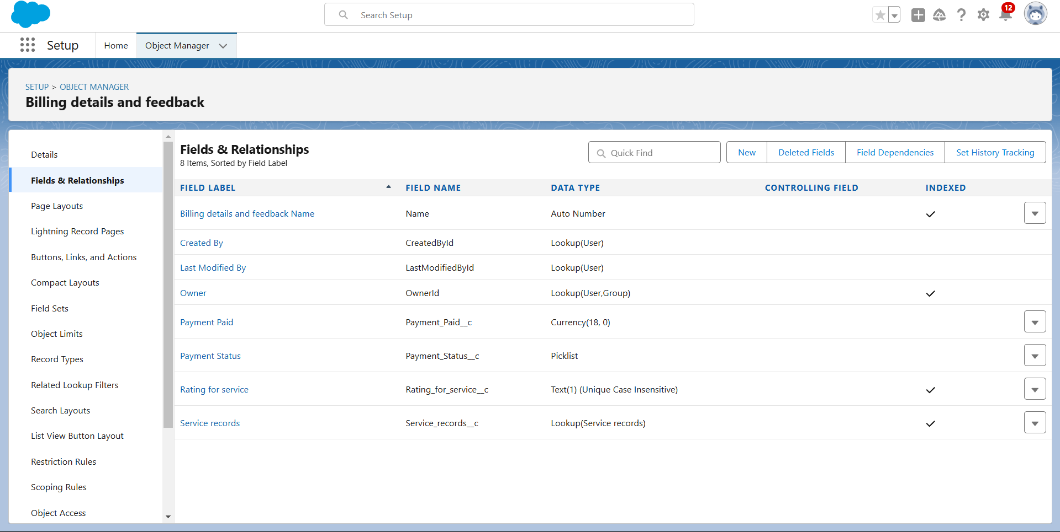

# Creation of Checkbox Fields

**Creation of CheckboxField on Appointment Object :**

1. Go to setup >>click onObject Manager >>type object name( Appointment ) in search bar >> click on the object.
2. Now click on “Fields & Relationships” >>New.
3. Select “Checkbox” as data type and click Next.
4. Give theField Label: Maintenance service
5. Field Name: is auto populated
6. Default value : unchecked
7. Click on nxt >>next >> save.

# Creation of AnotherCheckbox Field On Appointment Object:

1. Repeat the steps from 1 to 3.
2. Give theField Label : Repairs
3. Field Nme: is auto populated
4. Default value : unchecked
5. Click on next >>next >> save.
6. Follow the same and create another checkbox with given names
7. Give theField Label :Replacement Parts
8. Field Nme: is auto populated
9. Default value : unchecked
10. Click on nxt >> next >> save.

# Creation of CheckboxField on Servicerecords Object :

1. Go to setup >>click onObject Manager >>type object name( Service records) in search bar >>click on the object.
2. Now click on “Fields & Relationships” >>New.
3. Select “Checkbox” as data type and click Next.
4. Give theField Label :QualityCheck Status
5. Field Nme: is auto populated
6. Default value : unchecked
7. Click on nxt >>next >> save

# Creation of date Fields

**Creation of Date Field on Appointment Object:**

1. Go to setup >>click onObject Manager >>type object name( Appointment ) in the search bar >> click on the object.
2. Now click on “Fields & Relationships” >>New.
3. Select “Date” as data type and click Next.
4. Give theField Label :Appointment Date
5. Field Nme: is auto populated
6. Make itas a Required Field by click on the Required option.
7. Click onnext >>next >> save.

# Creation of CurrencyFields

**Creation of CurrencyField on Appointment Object :**

1. Go tosetup >>click onObject Manager >>type object name( Appointment ) in the

search bar >>click on the object.

1. Now click on “Fields& Relationships” >>New.
2. Select “Currency” as data type and click Next.
3. Give theField Label: Service Amount
4. Field Nme: is autopopulated
5. Click onnext
6. Give read only for allthe profiles infield level security for profile.
7. Click onnext > > save.

# Creation of CurrencyField on Billingdetails and feedbackObject :

1. Follow the same steps as mentioned above in Billing details and feedback Object.
2. Change thelabel name asmentioned.
3. Give theField Label :PaymentPaid
4. Field Nme: is autopopulated

# Creation of Text Fields

1. Go tosetup >>click onObject Manager >>type object name( Appointment ) in the search bar >> click on the object.
2. Now click on “Fields & Relationships” >>New.
3. Select “Text” as data type and click Next.
4. Give theField Label :Vehicle number plate
5. Field Name: is autopopulated
6. Length :10
7. Make field as Required andUnique.
8. Click onnext >>unext >> save.

# Creation of Text Fields in Billingdetails and feedbackobject :

1. Go tosetup >>click onObject Manager >>type object name( Billing detailsand feedback ) in search bar >> click on the object.
2. Now click on “Fields & Relationships” >>New.
3. Select “text” as data type and click Next.
4. Give theField Label: Rating for service
5. Field Name: is autopopulated
6. Length :1
7. Make field as Required andUnique.
8. Click onnext >> next >> save

# Creation of PicklistFields

**Creation of PicklistFields in Servicerecords object:**

1. Go tosetup >>click onObjectManager >> typeobject name(Service records) in search bar >> click on the object.
2. Click onfields & relationship >> click onNew.
3. Select Data type as “Picklist” and click Next.
4. Enter Field Label as “Service Status”,under values select“Enter values, with each value separated by a new line" and enter values as shown below.
5. The values are: Started, Completed.
6. Click Next.
7. Next >> Next >>Save.

# Creation of Picklist FieldsinBilling detailsand feedbackobject:

1. Go tosetup >>click onObject Manager >>type object name(Billing details and feedback) in search bar >> click on the object.
2. Click onfields & relationship >> click onNew.
3. Select Data type as “Picklist” and click Next.
4. Enter Field Label as “Payment Status”,under values select“Enter values, with each value separated by a new line" and enter values as shown below.
5. The values are: Pending, Completed.
6. Click Next.
7. Next >> Next >>Save.

# Creating Formula Fieldin ServicerecordsObject

1. Go tosetup >>click onObjectManager >> typeobject name(Service records) in search bar >> click on the object.
2. Click onfields & relationship >> click onNew.
3. Select Data type as “Formula” and click Next.
4. Give Field Label and Field Name as “servicedate” and select formula return type as “Date” and click next.
5. Insert field formulashould be : CreatedDate
6. click “Check Syntax” .
7. Click next >> next >> Save.

# Validation rule

Validation rules are appliedwhen a user triesto save a record and are used to checkifthe data meets specifiedcriteria.If the criteriaare not met, the validation rule triggers an error message and prevents the user from savingthe record untilthe issuesare resolved.

# To create a validation rule to an Appointment Object

1. Go tothe setuppage >> click on objectmanager >> From drop down click edit for Appointment object.
2. Click onthe validation rule >> clickNew.
3. Enter theRule name as“ Vehicle ”.
4. Insert theErrorCondition Formula as: -

NOT(REGEX( Vehicle_number_plate c , "[A-Z]{2}[0-9]{2}[A-Z]{2}[0-9]{4}"))

5.Enter the ErrorMessageas “Please enter vaild number”,select the Errorlocationas

Field and selectthe field as “Vehiclenumber plate”, and click Save.

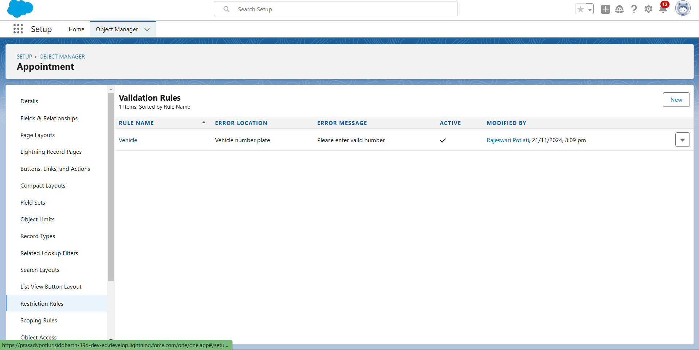

# To create a validation rule to an Service recordsObject

1. Go tothe setuppage >> click on objectmanager >> From drop down click edit for Service records object.
2. Click onthe validation rule >> clickNew.
3. Enter the Rule name as “ service_status_note ”.
4. Insert theErrorCondition Formula as: -
5. NOT( ISPICKVAL( Service_Status c , "Completed"))
6. Enter theError Messageas “still it is pending”,select theError location asField and select the field as “Service status”, and click Save

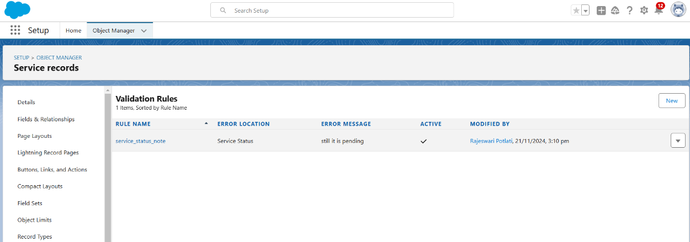

# 

# To create a validation rule to an Billing detailsand feedback Object

1. Go tothe setuppage >> clickon object manager>> Fromdrop down clickedit for Billing details and feedback object.
2. Click onthe validation rule>> click New.
3. Enter theRule name as“ rating_should_be_less_than_5”.
4. Insert theErrorCondition Formula as: - NOT( REGEX( Rating_for_service c , "[1-5]{1}"))

5.Enterthe ErrorMessage as “ratingshould be from 1 to 5”, selectthe Errorlocationas Field and select the field as “Rating for Service”, and click Save.

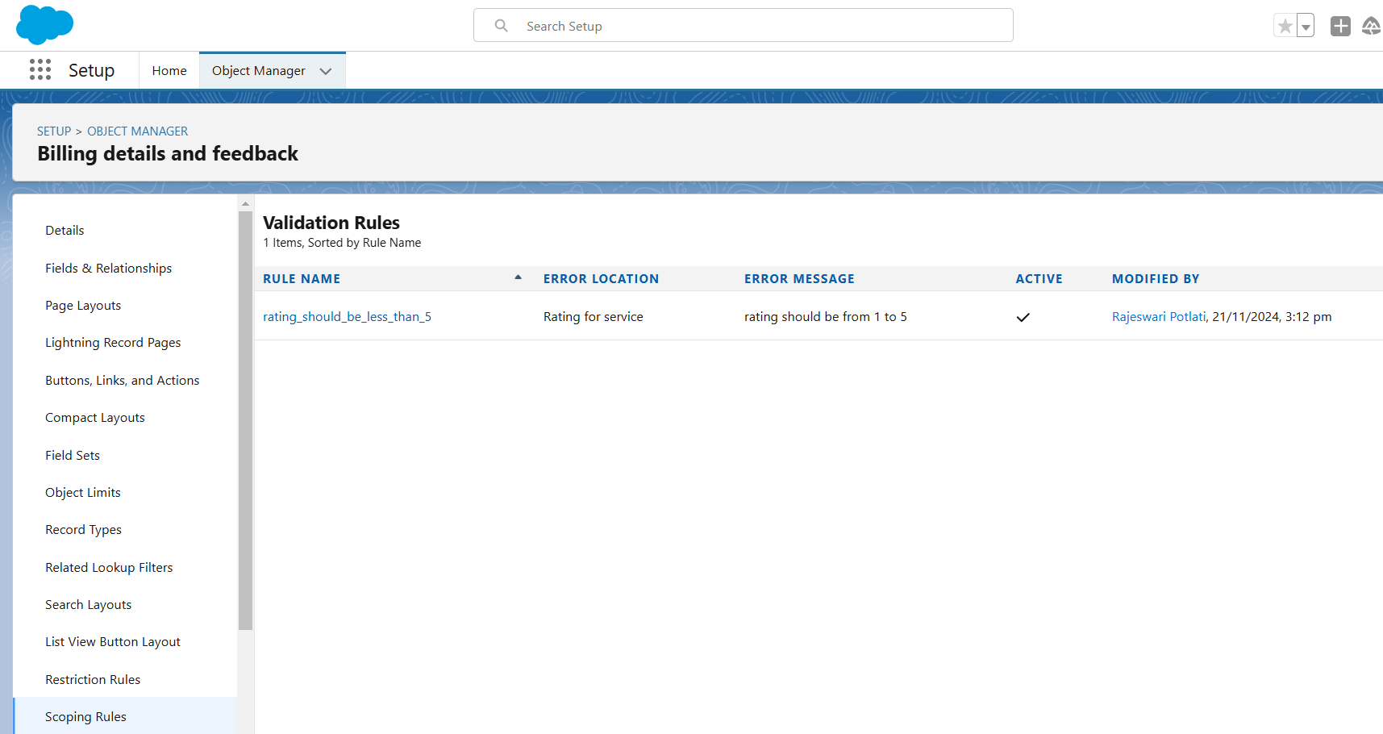

# Duplicate rule

**To create a matching rule to an Customer detailsObject**

1. Go toquick find boxin setup andsearch for matchingRule.
2. Click onmatchingrule >> click on New Rule.
3. Select theobject as Customer detailsand click Next.
4. Give the Rule name : Matching customer details
5. Unique name: is autopopulated
6. Define the matching criteria as
7. Field : MatchingMethod
8. Gmail:Exact
9. Phone Number:Exact
10. Click save.
11. After Saving Click on Activate.

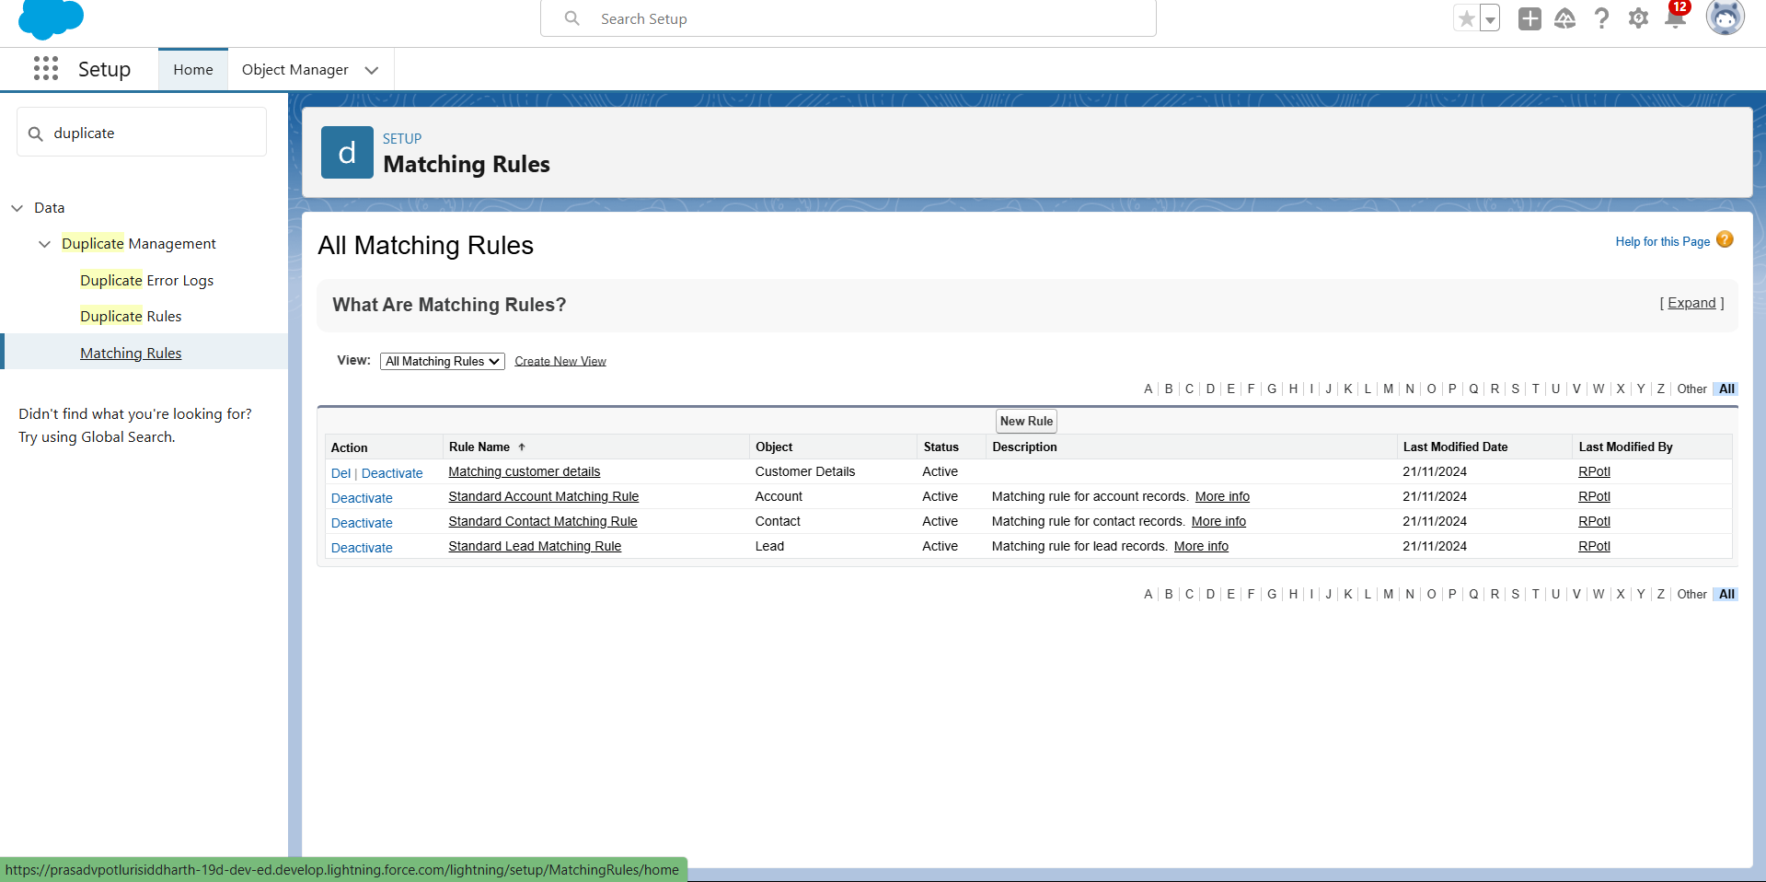

# To create a Duplicate rule to an Customer detailsObject

1. Go toquick find boxin setup andsearch for Duplicate rules.
2. Click onDuplicate rule >> click on NewRule >>select customer detailsobject.
3. Give theRule name as: CustomerDetail duplicate
4. Scroll a little in Matching rule section
5. Select the matching rule : Matching customer details
6. And Click on save.
7. After saving the Duplicate Rule, Click on Activate.

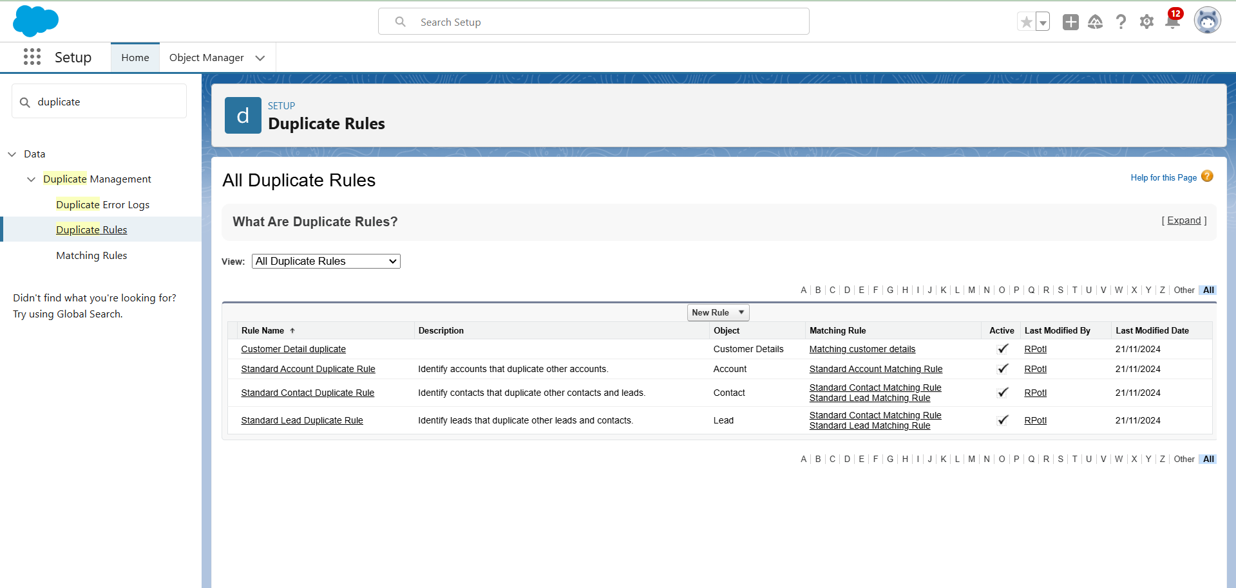

# Profiles

A profile is a group/collection of settings and permissions that define what a user can do in salesforce. Profile controls“Object permissions, Field permissions, User permissions, Tab settings, App settings, Apex class access,Visualforce page access,Page layouts,Record Types, Login hours& Login IP ranges. You can defineprofiles by the user'sjob function. For example System Administrator, Developer, Sales Representative.

# Manager Profile

**To create a new profile:**

* 1. Go tosetup >>type profiles in quick find box >>click onprofiles>> clone the desired profile (Standard User) >>enter profile name (Manager) >> Save.
  2. While still on the profilepage, then click Edit.
  3. Select the Custom App settingsas default for theGaragemanagement.
  4. Scroll down to Custom Object Permissions and Give access permissions for Appointments,Billing detailsand feedback , service recordsand customer details objects as mentioned in the below diagram.
  5. Changing thesessiontimes out after should be “8 hours ofinactivity”.
  6. Change the password policies as mentioned :
  7. User passwords expire in should be “ never expires ”.
  8. Minimum password lengthshould be “8 ”, and clicksave.

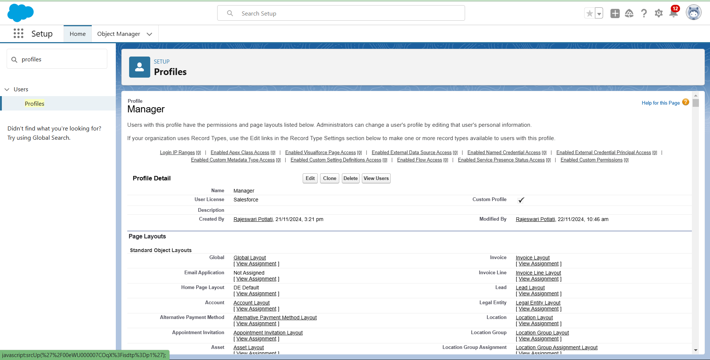

# Sales person Profile

1. Go tosetup >>type profiles in quick find box >>click onprofiles>> clone the desired profile (Salesforce PlatformUser) >> enter profile name (sales person)>> Save.
2. While still on the profilepage, then click Edit.
3. Select theCustomApp settings asdefault for theGAragemanagement.
4. Scroll down to Custom Object Permissions and Give access permissions for Appointments,Billing detailsand feedback , service recordsand customer details objects as mentioned in the below diagram. And click save.

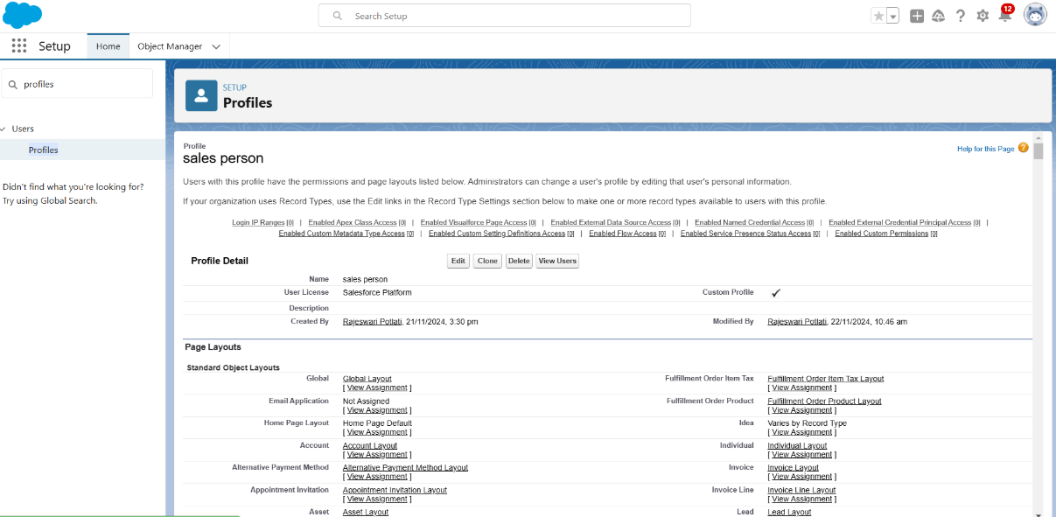

# Role & Role Hierarchy

A role in Salesforce definesauser's visibility accessat the record level.Roles may be used to specify the types of access that people in your Salesforce organization can have to data. Simply put, it describes what a user could see within the Salesforce organization.

# Creating Manager Role

* 1. Go toquick find >> Searchfor Roles >>click on set uproles.
  2. Click onExpand All andclick on addrole under whom this role works.
  3. Give Label as “Manager” and Role name gets auto populated. Then click on Save.

# Creating another roles

1. Go toquick find >> Searchfor Roles >>click on set uproles.
2. Click pluson CEO role, and click addrole under manager.
3. Give Label as “sales person” and Role namegets auto populated. Then click on Save.

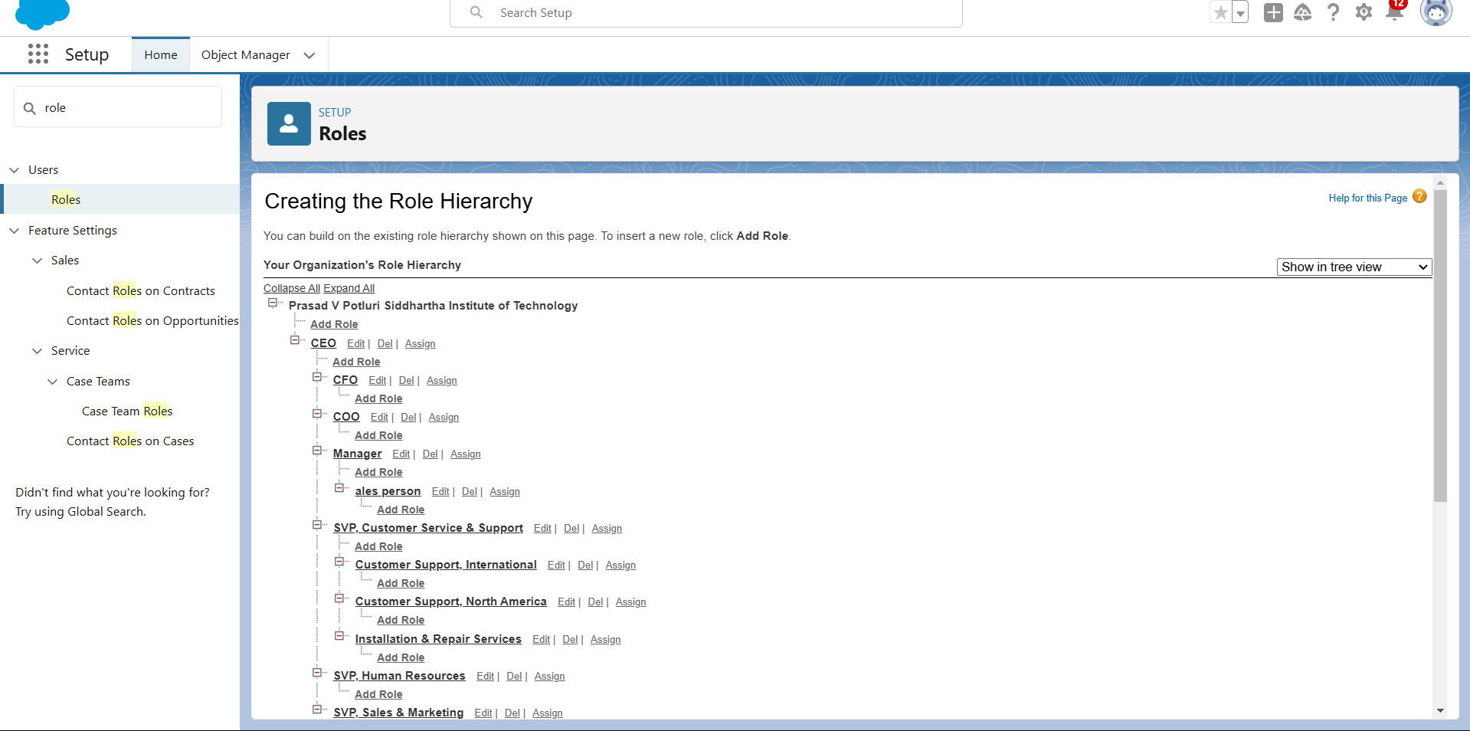

# Users

A user is anyone who logs in to Salesforce. Users are employees at your company,such as sales reps,managers, and IT specialists, who need accesstothe company's records.Everyuser in Salesforce has a user account. The user accountidentifies the user,and the user account settings determine what features and records the user can access.

# Create User

1. Go tosetup >>type users in quick findbox >>select users >>click New user.
2. Fill inthe fields
   1. First Name : Niklaus
   2. Last Name : Mikaelson
   3. Alias :Give a Alias Name
   4. Email id: Give your Personal Emailid
   5. Username : Username should be in this form: [text@text.text](mailto:text@text.text)
   6. Nick Name : Give aNickname
   7. Role :Manager
   8. User licence : Salesforce
   9. Profiles :Manager
3. Save.

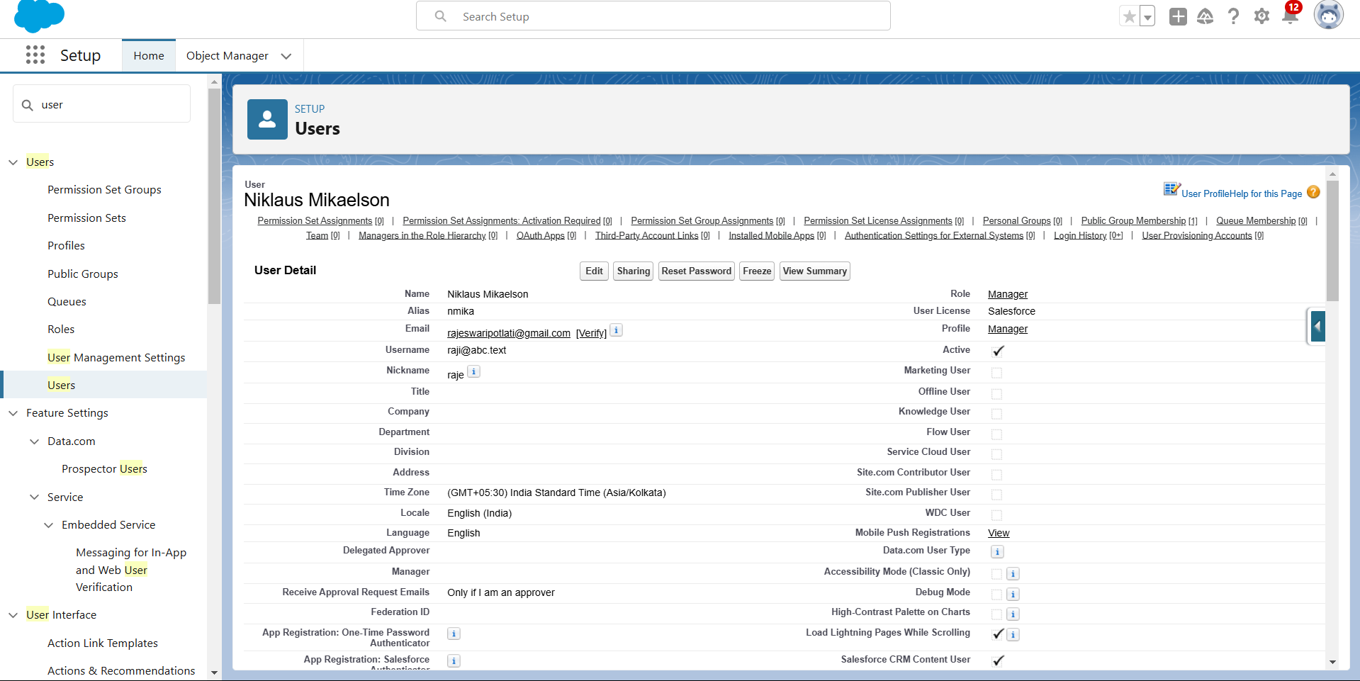

# creating another users

1. Repeat the steps and create another user using
   1. Role : sales person
   2. User licence :Salesforce Platform
   3. Profile :sales person

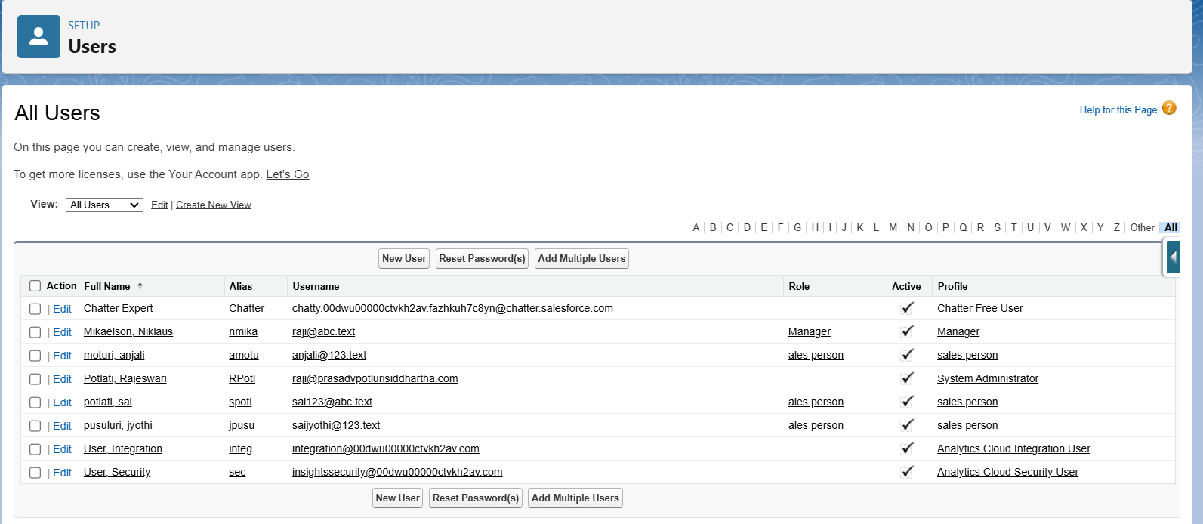

# Note : create atleast3users with these permissions.

**Public groups**

Public groups are a valuabletool for Salesforce administrators and developers to streamline user management, data access, and security settings.By creating and using public groups effectively, you can maintaina secure and organized Salesforce environment while ensuringthat users have appropriate access to the resources they need.

# Creating New Public Group

1. Go tosetup >> typeusers in quick find box >>select public groups>> click New.
2. Give the Label as “sales team”.
3. Group nameis autopopulated.
4. Search forRoles.
5. In Available Members selectSales person and click onadd it will be moved toselected member.
6. Click onsave.

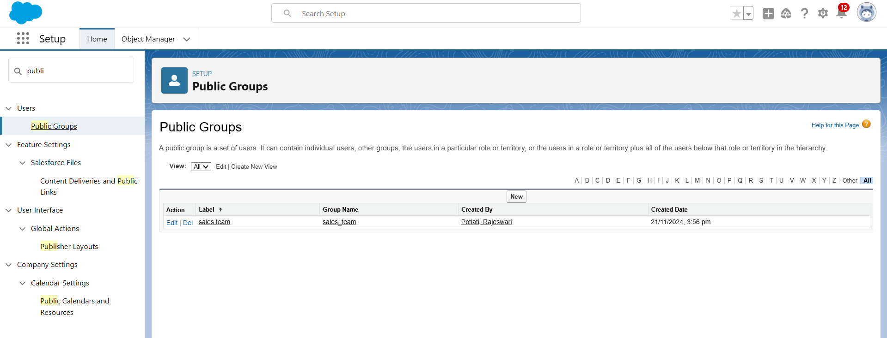

# Sharing Setting

Salesforce allows you to configuresharingsettings to controlhow records are accessedand shared within your organization. These settings are crucial for maintaining data security and privacy. Salesforce provides a variety of tools and mechanisms to define and enforce sharing rules, such as:

# Organization-Wide Default (OWD) Settings:

These settings definethe default levelof accessfor all objectswithin your Salesforce org. OWD settings include Private, Public Read-Only, Public Read/Write, and Controlled by Parent. OWD settings can be configured for each standard and custom object.

# Role Hierarchy:

Salesforce uses a role hierarchy to determine record access.

Usersat higher levelsinthe hierarchy have greateraccess to recordsowned by or sharedwith users lower in the hierarchy.

The role hierarchy is often used in combination with OWD settingsto grant different levelsof access.

# Profiles and Permission Sets:

Profiles and permission sets allow administrators to specify object-level and field-level permissions for users.

Profiles are typicallyused to grant generalobject and field access, while permission sets can be used to extend those permissions to specific users.

# Creating Sharing settings

1. Go tosetup >>type users in quick findbox >>select Sharing Settings>> click Edit.
2. Change theOWD settingof theService records Objectto private as shown in fig.
3. Click onsave and refresh.
4. Scroll downa bit, Click new on Servicerecords sharing Rules.
5. Give theLabel name as“ Sharing setting”
6. Rule nameis auto populated.
7. In step3 : Select which records tobe shared,members of“ Roles ” >> “Sales person”
8. In step4: sharewith, select “ Roles ”>> “ Manager ”
9. In step5 : Changethe access levelto “Read / write ”.
10. Click onsave.

# Flows

**Create a Flow**

1. Go tosetup >>type Flowin quick findbox >>Click onthe Flow andSelect the New Flow.
2. Select the Record-triggered flow and Click on Create.
3. Select the Object as “Billing details and feedback”in the Drop down list.
4. Select theTrigger Flow when: “A record isCreated or Updated”.
5. Select the Optimize the flow for: “Actions and Related Records” and Click on Done.
6. Under theRecord-triggered Flow Click on “+” Symboland In the Dropdown List select the “Update records Element”.Give the Label Name : Amount Update
7. Api name: is autopopulated
8. Set afilter condition :All Conditions aremet(AND)
9. Field :Payment_Status c
10. Operator : Equals
11. Value :Completed
12. And SetField Values forthe Billingdetails andfeedbackRecord
13. Field :Payment_Paid c
14. Value : {!$Record.Service_records r.Appointment r.Service_Amount c}
15. Click OnDone.Before creating another Element.Create a NewResource form Toolbox form top left.
16. Click onthe New Resource,And select Variable.
17. Select theresourcetype as text template.
18. Enter theAPI name as“ alert”.
19. Change theview as Rich Text ? View to Plain Text.
20. In bodyfieldpaste the syntaxthat given below.

Dear {!$Record.Service_records r.Appointment r.Customer_Name r.Name},

I hope this message findsyouwell. I wantedto take a moment to express my sincere gratitude for your recent paymentfor the servicesprovided by our garagemanagement team. Your prompt paymentis greatly appreciated, and it helps us continue to provide top-notch services to you and all our valued customers.

Amount paid : {!$Record.Payment_Paid c} Thank you for Coming .

1. Click done.
2. Now Click on Add Element, select Action.
3. Their action bar will beopened in that searchfor “ sendemail ” andclick on it.
4. Give thelabel name as“ Email Alert”
5. API name will be auto populated.
6. Enable thebody in setinput values forthe selected action.
7. Select thetext template thatcreated , Body: {!alert}
8. Include recipient address list select the email form the record.
9. RecipientAddressList:

{!$Record.Service_records r.Appointment r.Customer_Name r.Gmail c}

1. Include subject as “ Thank You for Your Payment - Garage Management”.
2. Click done.
3. Click onsave. Give theFlow label ,Flow Api name will be autopopulated.
4. And click save, and click on activate.

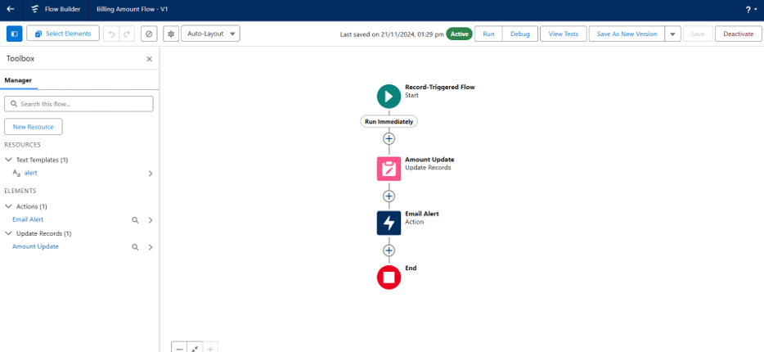

# 

# Apex Trigger

Apex can be invoked by using triggers. Apex triggers enableyou to perform customactions before or after changes to Salesforce records, such as insertions, updates, or deletions.

Atriggeris Apex code that executesbefore or after the following types of operations:

* 1. insert
  2. update
  3. delete
  4. merge
  5. upsert
  6. undelete

For example, you can have a triggerrun before an object'srecordsare inserted into the database, after recordshave been deleted,or even aftera recordis restored from the Recycle Bin.

You can definetriggers for top-levelstandard objectsthat support triggers, such as a Contact or an Account, some standard child objects, such as a CaseComment, and custom objects. To define a trigger, from the objectmanagement settings for the objectwhose triggersyou want to access, go to Triggers.

There are primarilytwo types of Apex Triggers:

**Before Trigger:** This type of trigger in Salesforce is used either to update or validate the values of a recordbefore they can be savedinto the database. So, basically, the before triggervalidates the recordfirstand then savesit.Some criteriaor code can be set to checkdata beforeit gets ready to be inserted into the database.

**After Trigger:** This type of trigger in Salesforce is used to access the field values set by the system and affect any change in the record.In other words, the after trigger makes changes to the value from the data inserted in some other record.

# Apex handler

UseCase : This use case works for Amount Distribution for each Servicethe customer selected for there Vehicle.

1. Login tothe respective trailhead account and navigate to the gearicon in thetop right corner.
2. Click onthe Developer console.Now you will seea new consolewindow.
3. In thetoolbar, you cansee FILE. Clickon it and navigate to new andcreate New apex class.
4. Name the class as “AmountDistributionHandler ”.

# Code:

public class AmountDistributionHandler {

public static void amountDist(list<Appointment c> listApp){ list<Service_records c> serList= new list <Service_records c>(); for(Appointment c app : listApp){

if(app.Maintenance_service c == true && app.Repairs c == true && app.Replacement_Parts c == true){

app.Service_Amount c = 10000;

}

else if(app.Maintenance_service c == true && app.Repairs c == true){ app.Service_Amount c = 5000;

}

else if(app.Maintenance_service c == true && app.Replacement_Parts c == true){ app.Service_Amount c = 8000;

}

else if(app.Repairs c == true && app.Replacement_Parts c == true){ app.Service_Amount c = 7000;

}

else if(app.Maintenance_service c == true){ app.Service_Amount c = 2000;

}

else if(app.Repairs c == true){ app.Service_Amount c = 3000;

}

else if(app.Replacement_Parts c== true){ app.Service_Amount c = 5000;

}

}

}

}

# Trigger Handler :

How to create a new trigger :

1. While still in the trailhead account, navigate to the gear icon in the top right corner.
2. Click ondeveloper consoleand youwill be navigatedto a new console window.
3. Click onFile menu inthe tool bar,and click onnew? Trigger.
4. Enter thetrigger name andthe object tobe triggered.
5. Name :AmountDistribution
6. sObject :Appointment c

# Syntax For creating trigger:

The syntax for creating trigger is :

Trigger [trigger name] on [object name]( Before/After event)

{

}

In this project, triggeris called wheneverthe particular recordssum exceed the thresholdi.e minimum business requirement value.Then the code in the trigger will get executed.

Code:

trigger AmountDistribution on Appointment c (before insert,before update) { if(trigger.isbefore && trigger.isinsert || trigger.isupdate){

AmountDistributionHandler.amountDist(trigger.new);

}

}

# Reports

Reports give you access to your Salesforce data. You can examine your Salesforce data in almost infinite combinations, display it in easy-to-understand formats,and share the resulting insights with others. Beforebuilding,reading, and sharingreports, review these reportingbasics.

Types of Reports in Salesforce

1. Tabular
2. Summary
3. Matrix
4. Joined Reports

# create a report folder

1. Click onthe app launcher and search forreports.
2. Click onthe report tab, click on newfolder.
3. Give theFolder labelas “Garage Management Folder”, Folder uniquename will beauto populated.
4. Click save.

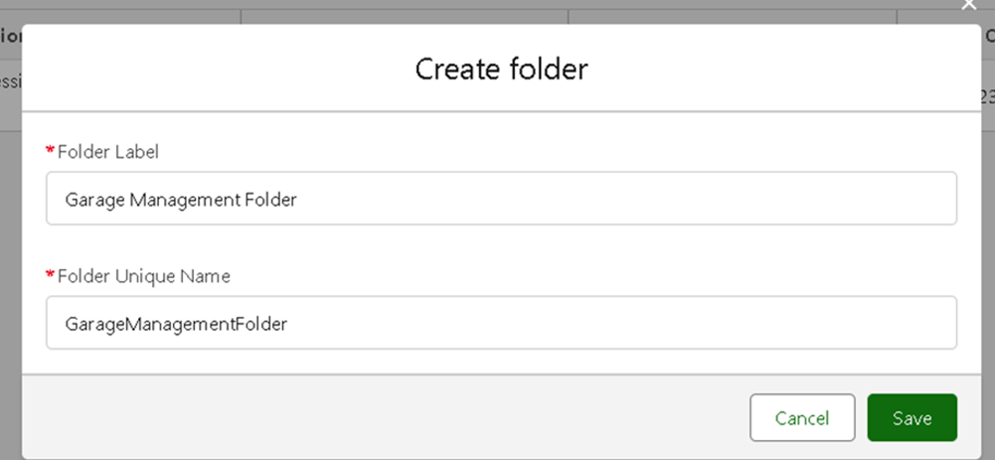

# Sharing a report folder

1. Go tothe app >>click on the reports tab.
2. Click onthe All folder , click onthe Drop downarrow for Garage Management folder,and Click on share.
3. Select theshare with as“roles”,in name field search for “manager”, give “view” as access for that role.
4. Then click share, and click on Done.

# Create Report Type

1. Go tosetup >> type users in quick find box >>select Report Type >> click on Continue.
2. Click onnew custom reporttype.
3. Select the Primary object as “ Customer details” .
4. Give theReporttype Label as“ Serviceinformation ”
5. Report typeName is autopopulated.
6. Keep the Description as same.
7. Select Store in Category as“ otherReports ”
8. Select the deployment status as “ Depolyed ”, click on Next.
9. now , Click onRelatedobject box.
10. Click onSelectObject, choose Appointment Object as shownin fig
11. Again Click to relate anotherobject.
12. And select the related objectas “ service records”.
13. Repeat the process and select the related object as “ Billing details and feedback”.
14. And click on save.

# Create Report

Note : Before creating report,create latest “10” recordsin every object. Try to fill every field in each record for better experience.

1. Go tothe app >>click on the reports tab
2. Click NewReport.
3. Select theCategory as other reports,search for ServiceInformation, select that report, click on it. And click on start report.
4. Their outline pane is opened alredy,select the fields that mentionedbelow incolumn section.
   1. Customer name
   2. Appointment Date
   3. Service Status
   4. Payment paid
   5. Remove the unnecessary fields.
   6. Select thefields that mentioned below in GROUP ROWS section.
      1. Rating forService
   7. Select thefields that mentioned below in GROUP ROWS section.
      1. Payment Status
   8. Click onAdd Chart ,Select the Line Chart.
   9. Click onsave, Give the reportName : NewService information Report
   10. Report unique Name is auto populated.
   11. Select the folder the createdand Click on save.

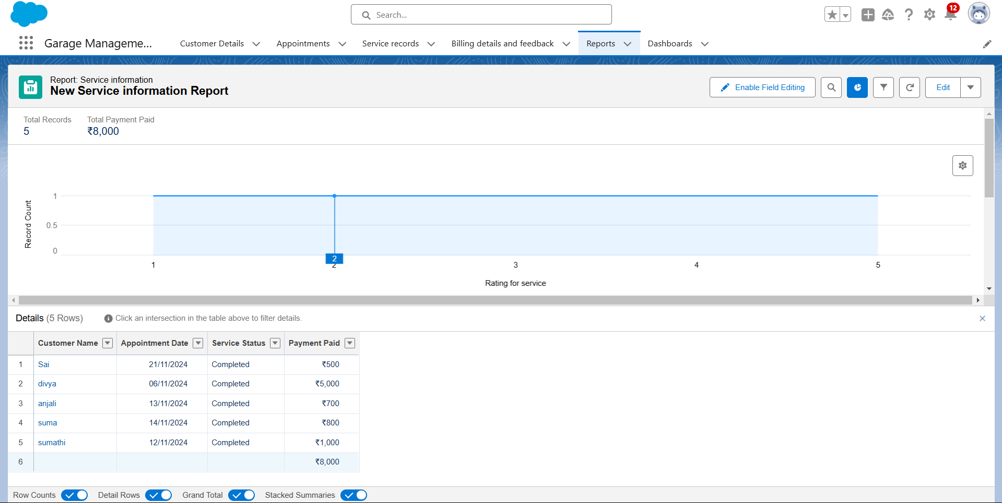

# Dashboards

Dashboards help you visually understand changing business conditions so you can make decisions based on the real-time data you’ve gathered with reports. Use dashboards to help users identifytrends, sort out quantities, and measure the impact of their activities. Before building, reading, and sharing dashboards, review these dashboardbasics.

# Create Dashboard Folder

1. Click onthe app launcher and search fordashboard.
2. Click on dashboard tab.
3. Click newfolder,give the folderlabel as “ Service Ratingdashboard”.
4. Folder unique name will beauto populated.
5. Click save.
6. Follow thesame steps,form milestone 15, and activity2, and provide thesharing settings for the folder that just created.

# Create Dashboard

1. Go tothe app >>click on the Dashboards tabs.
2. Give a Name andselect the folder that created, andclick on create.
3. Select addcomponent.
4. Select a Reportand click on select.
5. Select theLine Chart. Change the theme.
6. Click Addthen click onSave and thenclick on Done.
7. Preview is shown below.

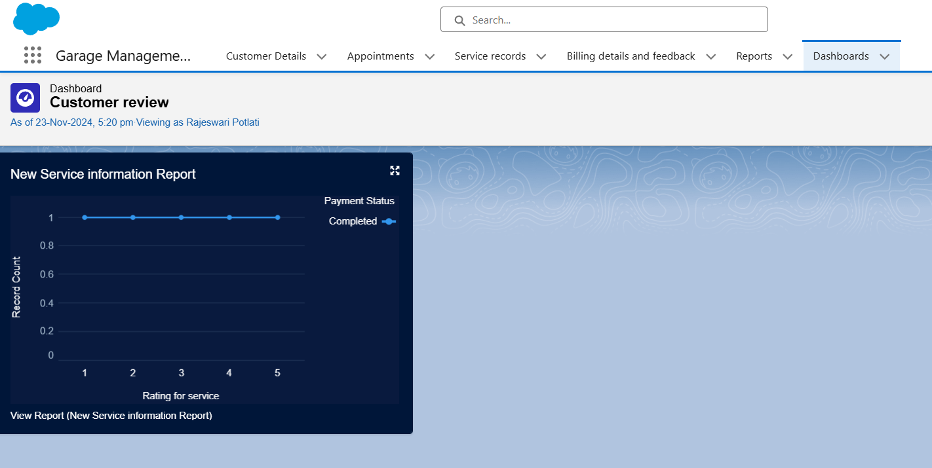

# Subcription:

1. After that Click on Subcribe on top right.
2. Set theFrequency as “weekly”.
3. Set aday as monday.
4. And Click on save.

